Travel information

Public transport: bus or train from Oslo Airport, Gardemoen to Kongsvinger

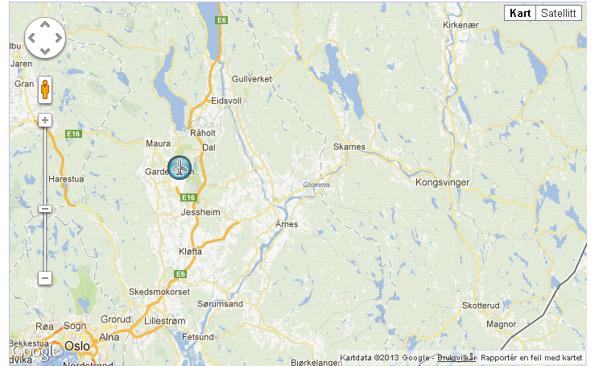

Bus:
Approx NOK 170. Payment in cash or by use of Nordic credit cards.
The busplatform is just opposite of the parking outside the arrival area. The platform area is under construction, and for the time being platform 22b is the accurate one – on the left hand side, across the parking house. This may change, but should still be easy to find as it is a limited area for buses.

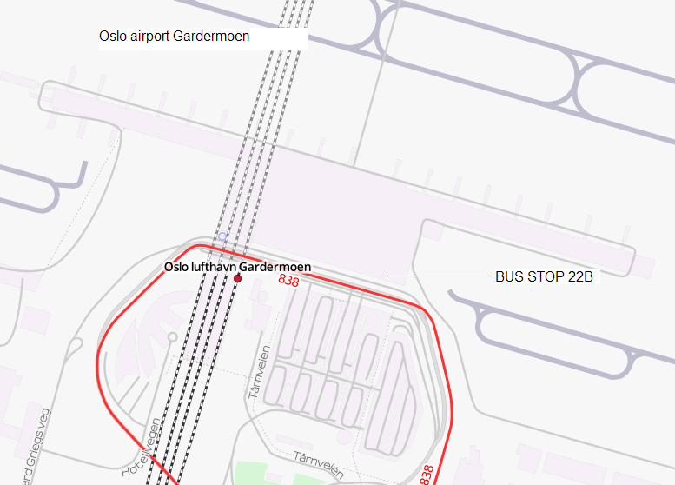

The bus leaves once per hour ; In the rush hours 14 minutes past every hour, most of the day 18 minutes past every hour. You could check the schedule at www.nettbuss.no as shown below. The bus is marked direction “Årnes” – just ask for correspondence to Kongsvinger.

Travelling time approx 1 hour and 20 minutes

Change of bus at Rød bus-stop, corresponding bus at the same platform, no waiting time. The bus is marked “Kongsvinger”.
In the example below, the bus leaves Gardemoen airport at 15.14 - reaches Rød bus-stop for change of bus at 15.41) and Kongsvinger railway station at 16:34.

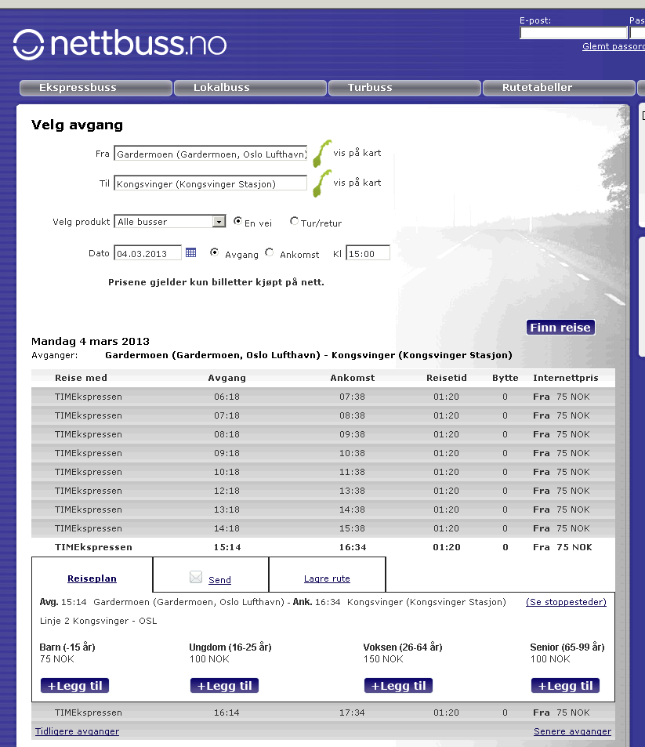

Railway: see www.nsb.no for time schedule and fares
Train from Oslo airport, Gardemoen to Lillestrøm, cahnge train at Lillestrøm
Train from Lillestrøm – Kongsvinger

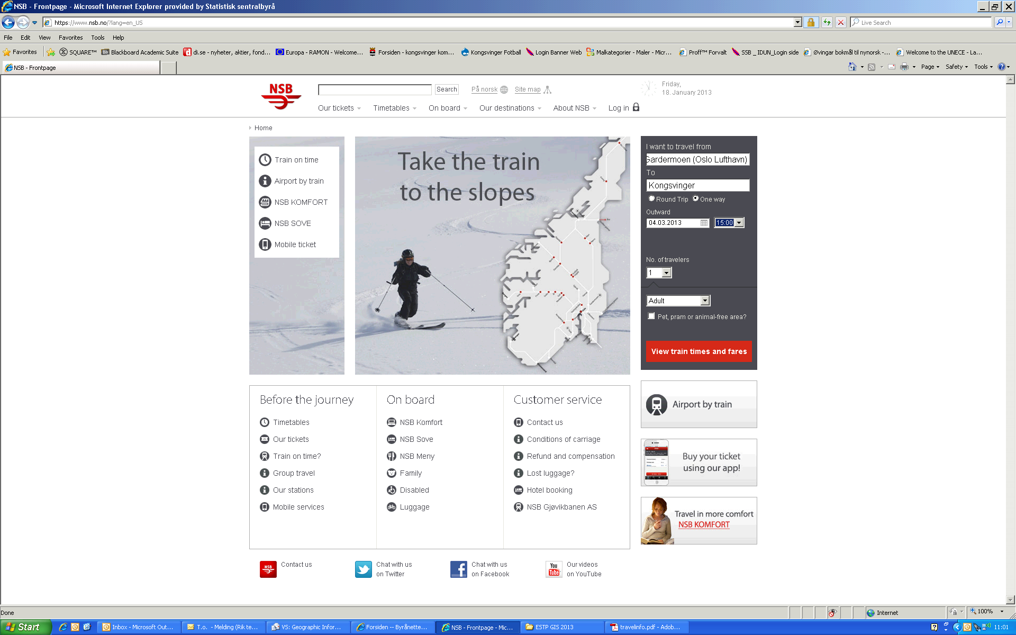

Example of time schedule:
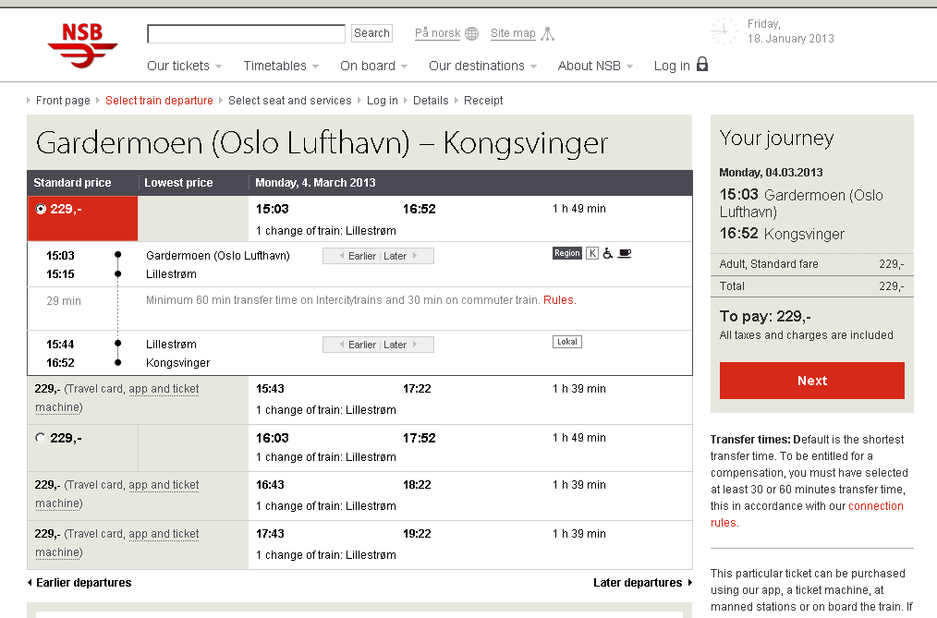
Kongsvinger railway station to Vinger Hotel

It is walking distances from the train station in Kongsvinger to Vinger hotel.
Follow the red line in the picture below. It takes you approx 10 minutes

With your back to the railway station, walk straight ahead to the main road in front of you. Turn left and follow the road for 250 meters to the roundabout, and cross over the two bridges. Turn left again and follow the road for 200 meters and you will see the hotel at your right hand side – just after a gas station.

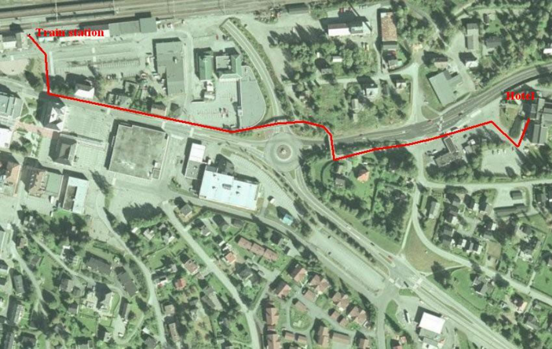

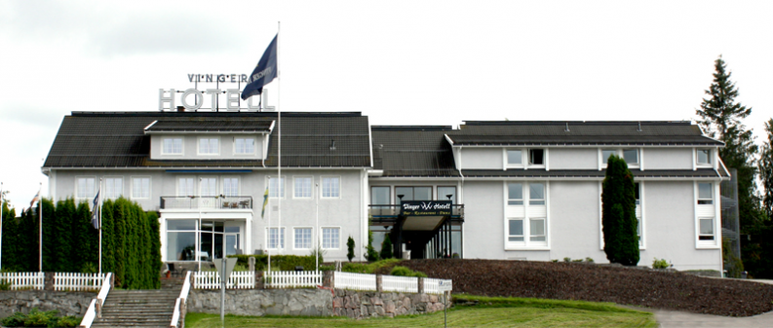

Vinger hotel to Statistics Norway
From the hotel to Statistics is about 20 minutes walking distance. There is also a city bus that goes by. Enter at Holt Sykehjem, bus number 501. Se map below.

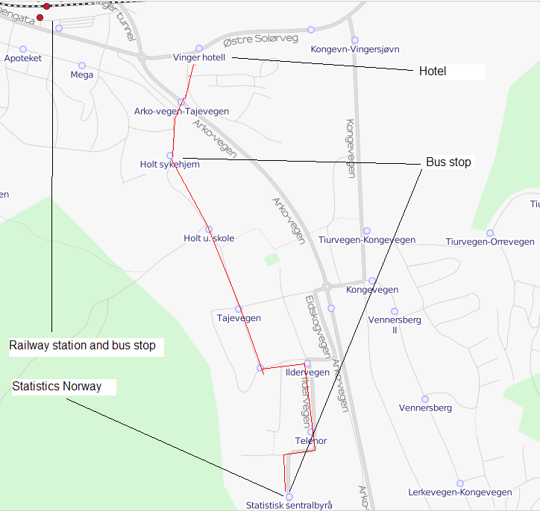

Statistics Norway – Kongsvinger
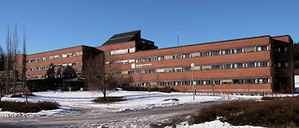
Going back to Oslo airport, Gardemoen by public transport:

The session will end Thursday March 7th at 14:00 o’clock.

The bus from Kongsvinger to the airport leaves 10 minutes to each hour from 03:50 to 20:50.

Taking a bus at 14:50 from Kongsvinger railway station will bring you to Oslo airport at 16:14.
Changing bus at Rød bus stop at approx 15.45.

http://www.nettbuss.no/www/resources/nbno/b/b4aa00bc1c59b9d1cdd07479070e355e.pdf



